**Rosa Parks Community School**



**FACULTY/STAFF HANDBOOK**

**2020-2021**

**\*PLEASE SIGN AND RETURN PAGE 41**

**“We must live our life as a model for others.” ~~~Rosa Parks**

|  |  |  |  |  |  |  |
| --- | --- | --- | --- | --- | --- | --- |
| ORANGE TOWNSHIP BOARD OF EDUCATION | | | | | | |
| Tyrone Tarver | | | | | | |
| *President* | | | | | | |
| Brenda Daughtry | | | | | | |
| *Vice President* | | | | | | |
| *Members* | | | | | | |
| *Guadalupe Cabido* | | *Derrick Henry* | | | | *Sueann Gravesande* |
| *Cristina Mateo* | | *Siaka Sherif* | | | | *Shawneque Johnson* |
| |  |  |  | | --- | --- | --- | |  | *Jeffrey Wingfield* |  | | | | | | | |
|  | | | | | | |
| **SUPERINTENDENT OF SCHOOLS** | | | | | | |
| **Gerald Fitzhugh, II, Ed.D.** | | | | | | |
|  |  | | | | | |
|  | **BUSINESS ADMINISTRATOR / BOARD SECRETARY** | | | | | |
|  | Adekunle O. James | | | | | |
| **EXECUTIVE DIRECTOR OF HUMAN RESOURCES** | | | | | | |
| Glasshebra Jones-Dismuke | | | | | | |
| **DIRECTORS** | | | | | | |
| Karen Harris, *English* *Language Arts/Testing* | | | Tina Powell, Ed.D., *Math/Science* | | | |
| Shelly Harper, *Special Services* | | | Terri Russo, D.Litt., *Curriculum & Instruction* | | | |
| **PRINCIPALS** | | | | | | |
| Faith Alcantara, *Heywood Avenue School*  Myron Hackett, Ed.D., *Park Avenue School* | | | | | | |
| Jason Belton, *Orange High School* | | | | | Karen Machuca, *Scholars Academy* | |
| Jacquelyn Blanton, *Orange Early Childhood Center* | | | | | Dana Gaines*, Oakwood Avenue Community School* | |
| Debra Joseph-Charles,Ed.D., *Rosa Parks Community School* | | | | | Denise White, *Central Elementary School* | |
| Yancisca Cooke*,* Ed.D*., Forest Street Community School* | | | | | Erica Stewart, Ed.D., *Twilight Program* | |
| Cayce Cummins, Ed.D*., New Early Childhood Center* | | | | | Robert Pettit, *Cleveland Street School (OLV)* | |
| Frank Iannucci, Jr*., Lincoln Avenue School* | | | | Salvatore Lima, Jr., *STEM Academy of the Oranges* | | |
| Carrie Halstead - Orange Preparatory Academy | | | | | | |
| **ASSISTANT PRINCIPALS** | | | | | | |
| Patrick Yearwood, *Lincoln Avenue School* | | | | | Nyree Delgado*, Forest Street Community School* | |
| Anthony Frantantoni, *Orange High School/Athletic Director* | | | | | Devonii Reid, Ed.D.,*STEM Academy of the Oranges* | |
| Oliverto Agosto, *Orange Preparatory Academy* | | | | | Joshua Chuy, *Rosa Parks Community School* | |
| Terence Wesley, *Rosa Parks Community School* | | | | | Gerald J. Murphy, *Heywood Avenue School* | |
| Samantha Sica-Fossella, *Orange Preparatory Academy* | | | | | Shadin Belal, Ed.D., *Orange Preparatory Academy* | |
| Kavita Cassimiro, *Orange High School* | | | | | April Stokes, *Park Avenue School* | |
| Isabel Colon*, Lincoln Avenue School* | | | | | Noel Cruz, Dean of Students, *Lincoln Avenue School* | |
| **SUPERVISORS** | | | | | | |
| Olga Castellanos, *Math (K-4)* | | | | | Jahmel Drakeford, *CTE (K-12) & Health & Physical Education (K-7)* | |
| Tia Burnett, *Testing* | | | | | Henie Parillon*, Science (K-12)* | |
| Meng Li Chi Liu, *Math (9-12)* | | | | | Rosa Lazzizera, *ELA (3-7) & Media Specialist* | |
| Donna Sinisgalli, Ed.D, *Visual & Performing Arts* | | | | | Daniel Ramirez, *Math (5-8)* | |
| Linda Epps, *Social Studies 5-12/Technology Coordinators* | | | | | Kurt Mathews, *(8-12) ELA & Media Specialist* | |
| Janet MClouden, Ed.D.,*Special Services* | | | | | Caroline Onyesonwu, *Bilingual/ESL & World Languages* | |
| Adriana Hernandez, *ELA* (*K-2) & Media Specialist* | | | | | Frank Tafur, *Guidance* | |
| David Aytas*, STEM Focus (8-12)* | | | | | Amina Mateen*, Special Services* | |
|  | | | | |  | |

LETTER FROM THE PRINCIPAL

August 24, 2020

Dear Faculty and Staff,

Greetings and well wishes from the administrative team at Rosa Parks Community School to you and the members of your family. I hope you are keeping safe and that you have had some time to enjoy the summer with your family. As we look forward to the start of the 2020-2021 school year, we must first reflect on the 2019-2020 school year. First, I would like to commend the Rosa Parks Community School family for your resilience, determination, and assistance in ensuring the well-being of all our constituents during what can only be described as a difficult time for all. As we look forward to the beginning of the new school year, I would like to assure you that the Orange Public School District, in general, and the Rosa Parks Community School administrative team, in particular, are dedicated to working with you as we navigate the teaching and learning process even in times that are different to what we know as normal. To those joining us this year, a warm welcome and we look forward to your contribution to this amazing team of educators.

In July, RPCS was redesigned to reflect a campus model. The students in grades Kindergarten through grade 2 were assigned to the new Central Elementary School. Students in grades three through seven were assigned to RPCS. My colleague and partner, Ms. Denise White, is now the proud principal of Central Elementary School. We have been working together all summer to continue all the great work that you are familiar with. We will continue this collaboration to ensure we move these two exceptional schools from Good to Great. Please join me giving her a warm welcome. I look forward to our work together.

As you are aware, there continues to be questions, concerns, anxiety, and uncertainty as it relates to the plan to reopen schools. The Superintendent, Dr. Gerald Fitzhugh, II has held several meetings, sent information, and held Orange Township City Hall meetings to address the district’s plans for reopening, allowing all stakeholders to be a part of the discussions on how to reopen safely. On Tuesday, August 11, 2020, the Board of Education approved Plan B, as outlined in the School Reopening Plan (please see the School Reopening Guidelines 2020-2021). Plan B will be structured to address the needs of our students while following the health and safety guidelines outlined by the Department of Education. Based on Plan B:

* September 8, 2020, through November 25, 2020 (Phases1 (100% Virtual Learning) and 2(Remote Synchronous), **all students will attend school virtually.**
* November 30, 2020, through December 23, 2020 (Phase 3 Soft Launch), **students needing additional support return to the site on an abbreviated schedule and day.**
* January 4, 2021, through June 24, 2021 (Phase 4: Full Re-Entry), **all students return to the site on an abbreviated schedule and day.**

Please see some extremely important information regarding new school procedures that align with the School Reopening Guidelines included in this handbook. We have outlined the expectations associated with operating in this time of our new normal. Please ensure that you read carefully. We will examine these and other important developments on September 1st and 4th, 2020. The dates are as follows for  **Open House Sessions** (September 2nd, and 3rd, 2020) and our **Back to School Night** (September 24, 2020). Please mark your calendars.

As always, I welcome your input. Please feel free to share any concerns, suggestions, or ideas to help ensure that we have a happy, healthy, and productive school year. I can be reached at josephde@orange.k12.nj.us or 973-677-4515.

In partnership,   
*Dr. Debra Joseph-Charles*

Principal

“Education is the most powerful weapon which you can use to change the world.”   
― [Nelson Mandela](https://www.goodreads.com/author/show/367338.Nelson_Mandela)

Vision

“The Orange Public School District commits to provide a safe and caring environment where each student is expected to grow and succeed. We pledge to prepare all students with equitable opportunities for college and career readiness, leading to lifelong learning and responsible citizenship in a competitive global community.”

Orange Public Schools Mission Statement

* The Orange Public School District in collaboration with all stakeholders is responsible for promoting the academic, social, emotional and personal success of all students.
* With a commitment to academic excellence, the District provides teachers, families, and administrators the tools needed for all students to reach their full potential.
* The District serves all students in our school, acknowledging their unique backgrounds, cultural perspectives, and learning styles.
* The District recognizes that curiosity, discipline, integrity, responsibility and respect are necessary for success.
* The Orange School District cultivates a community of 21st century learners where students take ownership of the learning process, achieve high standards of excellence, and focus on academics.

***From Good to Great***

**Rosa Parks Community School**

Vision  
As a Community School, our vision is to establish a solid foundation for lifelong learning by nurturing, guiding and inspiring all students to achieve their maximum potential. We will establish a viable partnership with parents, staff, students, and our community in order to make a positive and dynamic impact on the lives of ALL stakeholders.

Mission Statement

The staff of Rosa Parks Community School will provide a safe and caring environment where our lifelong learners, critical thinkers, and effective communicators. While working collaboratively with parents and the community, we will nurture all students, acknowledging their unique backgrounds and learning styles. The students of Rosa Parks Community School will achieve high standards of excellence, with the focus on academic and enrichment programs, through curiosity and creativity. The school community will maintain a high standard of integrity, responsibility, Respect, Pride, Courtesy and Safety. We are proud to educate our students of today; “Leave your mark” as leaders of tomorrow.

School Creed

I can, I must, I will succeed.  
I can do or become whatever I believe.   
I am smart, special, and valuable.  
I respect myself and others.  
My words and actions are kind and honest.  
I accept only my best in all that I do.  
I am dedicated to achieving excellence.  
I am PROUD to BE ME!

Administrative Team

**Debra Joseph-Charles Principal**

**Joshua Chuy Assistant Principal**

**Terence Wesley Assistant Principal**

The members of the Climate and Culture team collaborated on the construction of the contents of the Faculty/Staff Handbook. The members are listed below.

**Emmanuella Austin**

**Shannon Devose**

**Kaitlyn Kober**

**Natasha Murphy**

**Jean St. Fort**

**Tyrina Vaughan**

**Table of Contents**

Administrative Walkthroughs page 8

Assemblies page 8

Assessment Portfolios page 8-9

Attendance pages 9-10

Arrival Procedures pages 10-11

Assigned Extra Duties page 11

Bathrooms pages 11

Building Maintenance page 11

Bulletin Boards page 12

Cafeteria page 12

Classroom Environment pages12-13

Classroom Management page 13-14

Classroom Webpage pages 14

Common Planning Time/Small Learning Community page 14-15

Computer Use page 15

Copy Machines pages 15

Custodial Responsibilities page 15

Data Protocol page 15-16

Discipline Referrals pages 16-17

Distribution of Flyers and other correspondence page 17

Dismissal of Students pages 17-18

Developmental Cards page 18

Dress Down Days page 18

Employee Dress Code pages 18-19

Errands page 20

Evening Events page 20

Field Trips page 20

Films/Movies page 21

First Days of School page 21

Fund Raising/Monetary Transactions pages 21

Genesis and Email Issues page 22

Grading and Retention Guidelines page 22

Gradebook/Genesis pages 22-23

Harassment, Intimidation and Bullying page 23

Homework page 23-24

Interventions pages 24

Intervention and Referral Services pages 24-27

Lesson Plans pages 27-28

Lesson Plan Format page 28

Lockers pages 28-29

Lunch page 29

Master Calendar page 29

Morning Procedures/Routines page 29

Parking page 29

Phone Usage pages 30

Positive Behavior Model of Discipline page 30

Professional Conduct page 30

Purchase Orders page 30-31

Recess page 31

Restorative Justice page 31

Retention Guidelines page 31

Regular Fire and Safety Drills pages 32-34

Request for Supplies page 34

Safety page 34

School Communication page 34-35

School and Home Communication pages 35

School Nutrition/Snacks page 35

School Property page 36

Student Growth Objective page 36

Social Emotional Learning page 36

Social Networking Sites page 36

Staff Meetings /Professional Development/Inservice Opportunities page 37

Staff Observations and Evaluations pages 37

Stipend Sheets page 37

Student Attendance pages 37-38

Student Referral to Nurse’s Office page 38

Substitute Plans/Folders pages 38-39

Supervision of Students/Student Safety pages 39-40

Use of Building Facilities After Hours page 40

Vacation Activities page 40

Visitors page 40

Volunteers page 40

Faculty/Staff Signature Sheets page 41

Professional Responsibilities & Duties

*** Link for the Orange Board of Education Policies ***

For a comprehensive list of regulating policies visit the following website:

[**http://www.straussesmay.com/seportal/Public/pubElanOnline.aspx?id=c9b1aec93259447b8b1f420c50323b40**](http://www.straussesmay.com/seportal/Public/pubElanOnline.aspx?id=c9b1aec93259447b8b1f420c50323b40)

**Administrative Walkthroughs**

These will occur virtually, or in person once there is a return to the building and should be an integral part of our instructional day. Teachers will receive written effective feedback within 24 to 48 hours. Walkthroughs will be conducted using Orange Public School District Walkthrough Checklists (see opening day packet for details).

Data from all walkthroughs will be used to monitor our instructional practices and provide timely, focused support and professional development. Walkthrough checklists, guidelines and rubrics (Danielson Observation Tool) are provided in your Opening Day packets. All teachers/staff will be required to reflect and respond to comments/suggestions/guiding questions included in the feedback.

Administration will conduct walkthroughs virtually during synchronous instruction. This will be done during Google Meet sessions.

**Assemblies**

Assemblies are a regular part of the curriculum and as such are designed to be educational as well as entertaining experiences. They also provide in school opportunities for students to learn formal audience behavior/etiquette. Regardless of the type of program, courtesy demands that the school audience, including the student body, be respectful and appreciative.

Teachers and staff are required to supervise their assigned classes during assemblies. This means monitoring of student behavior and redirecting students if the need arises. Teachers and staff should model the behavior we expect students to demonstrate. If the assembly is occurring during Encores, classroom/subject teachers are to report promptly to pick up classes as per their schedules.

The same expectations will be in force of assemblies are conducted virtually.

During virtual assemblies, families will be provided a link to attend the meeting online.

**Assessment Portfolios**

Portfolios are to be maintained for every student by every teacher in every content area. Portfolio content must adhere to District mandates. Administrative Portfolio Reviews will be conducted quarterly by the administrative team. Your portfolios must be made available upon request. Each department will provide guidelines and protocols.

All staff is responsible for creating digital portfolios within their Google Classroom. When we return to school you may revert to past practice in your classroom or continue digitally.

**Attendance**

Arrival and Departure

Staff hours are 8:15-3:20 (teachers must remain after the dismissal of their classes as the discharge of their professional responsibilities require -Article XIV a. 3 teaching hours and teaching load). All staff are to be present and signed in by 8:15 AM. During remote learning, staff must checking for attendance. This can be by responding to the Principal directly or liking the morning message. **Secretaries** report for work from 8:00 am -3:30 pm. Sign in upon arrival using the Biometric system located by the Main Office. If you are unable to sign in using the Biometric system, you must sign in and out in the Main Office using the Staff Sign In Sheet. **Consistent tardiness/absenteeism could lead to disciplinary action up to and including withholding of increment.**

Sign out/in using the Staff sign out sheet if you are leaving the building during your scheduled lunch. Please note leaving the building during your planning period is contrary to acceptable practice. **Planning periods are to be used for planning. Teachers are not permitted to leave the building during this time.**

During Phase 1, instructional staff must indicate their presence by accessing the principal’s morning message by liking or sending received via email. This practice will continue on the days you are remote for Phase 2.

In the event of an absence, teachers must call the substitute service in Frontline (formerly AESOP) at 856-482-0300 by **6:00 am** on the day of the absence or go online to <https://login.frontlineeducation.com/login?signin=8af2ff323c415d951a6bc1c1b9e7b26a&productId=pd&clientId=pd#/login> before the day of absence. The substitute service must be notified for sick, personal, bereavement, professional days, in-service days, and field trips whether you require a substitute or not. Please note, secretaries may not complete this process for staff. **Please notify the office in the event of a delay or an emergency so that other arrangements can be made for supervision of your class.**

**Personal Days for Certified Employees require five days prior notification by the principal (Article XIX H. 2), non-certified employees require two days prior notification by the** principal **(Article XXXV111 D.3)** Please send an email to the principal as notification of personal days. Unless it is an emergency, you must follow this procedure.

Requests to attend professional meetings are to be discussed with the principal well in advance and requests must be submitted via My Learning Plan.

A copy of your attendance record may be obtained from the HR Payroll module on the Orange website.

If you are absent for 3 or more consecutive days, you **are** required to submit medical documentation to the principal. After six days of occasional absences, a formal conference will be held with the principal or his/her designee and the conference form will be submitted to the Human Resources Department. After eight days of occasional absences, HR will meet with the staff member.

**Consistent absence/tardiness can result in disciplinary action including withholding of increment /dismissal.**

**Arrival Procedures**

Upon arrival to school, students and staff temperature checks will be performed in accordance to Orange Public Schools reopening guidelines. The instructional staff must be at their assigned post by 8:15 a.m.

**D**uring Phase 1 (100% virtual), instructional staff will be ready to receive students by 8:25 a.m. At this time, all preparations to begin instruction would have taken place. Student attendance will be taken as students enter the Google Meet.

The instructional day begins promptly at 8:45 a.m. during Phase 1. Please refer to the School Reopening Guidelines for instructional start times during Phases 2-4. **On Monday, Tuesday, Thursday and Friday, all instruction is synchronous.** On **Wednesday, students will be involved in asynchronous learning while the staff is involved in Professional Development, planning sessions and meetings with students or parents.**

**Staff- Entry and exit will be as follows (Phases 2, 3, & 4):**

* **To gain entry you MUST wear a face covering.**
* **Through the gymnasium where you must have your temperature taken and recorded.**
* **Proceed directly to sign in. Each station has been outfitted with hand sanitizer. Please utilize after scanning in or signing in.**
* **Proceed directly to your classroom. Utilize the stairs rather than the elevator (only one person at a time)**
* **Refrain from using the side doors for entering and exiting. This is a mandate, not a request.**

Grades 3-7:

A parent will be called to pick up students that are showing symptoms of COVID-19 which include the following:

Does the child have any of the following symptoms in the past three days (72 hours):

* A cough
* Shortness of breath or difficulty breathing
* A fever of 100.4°F or higher or a sense of having a fever
* A sore throat
* Chills
* New loss of taste or smell
* Muscle or body aches
* Nausea/vomiting/diarrhea
* Congestion/running nose – not related to seasonal allergies
* Unusual fatigue
* Does anyone in your household have any of the above symptoms?
* Has your child been in close contact with anyone with suspected or confirmed case of COVID-19?
* Has your child had any medication before coming to school that would reduce a fever?

During Phases 3 and 4, students will enter through the gymnasium door both North and East entrances based on their report days and times. Staff will be placed at these doors to take and record temperatures. Students must report directly to their assigned classrooms.

1. Homeroom Procedures

**Take attendance in Genesis while students gather the materials needed for all classes prior to lunch**.

1. Breakfast will be Grab and Go in the students’ homeroom.

During Phases 3 and 4, the students will have breakfast during the block/period 1 class (teachers will use this time to **take attendance**, complete the Breakfast Count Sheet, collect homework, introduce the learning target, and require students to begin the Do Now/Anchor Task).

**Assigned Extra Duties (for example lunch duty, In-Class Support, morning posts, and classroom assignments)**

Every staff member who is assigned an extra duty, is expected to perform their specific assignment with fidelity. The staff member is to report promptly and remain on duty until completion. The staff member can only be excused from such duty by the principal/designee. The expectation is that the staff member actively monitors students to maintain a safe and healthy environment.

**Bathrooms\*\*\***

During Phases 3 & 4, the teachers must design and monitor a bathroom policy for his/her class. Teachers in grades 3-7 must enforce a sign out procedure indicating dates and times. Students must be informed that damage to school property is a serious disciplinary infraction and would be treated as such. Encourage your students to report any writing, damage, or inappropriate behavior to you immediately. This must be communicated to the main office personnel immediately.

Students are expected to remain in the classroom for the duration of the class period to benefit from the full lesson. The teachers will restrict the use of passes. They will be issued for emergencies only, to permit a student to use the lavatory or to seek medical attention. The students in the corridors must at all times have a pass ***(ONE PASS PER STUDENT).*** Please ensure that students are not leaving the classroom together. Abuse of privilege is the teacher’s responsibility to correct.

Any student that is excused from the room with a pass must sign their name, destination, time out and time in on a virtual Sign In/Sign Out Log. Teachers must monitor this process.

**Building Maintenance**

Repairs or maintenance items need a building maintenance request form from the main office.  If there is a problem in your room, please notify the secretary and carbon copy the building principal in writing as soon as possible. Heating and air conditioning issues are examples of problems that should be reported immediately.

**Bulletin Boards**

Bulletin boards are an important part of your classroom.  They should be kept current and used appropriately to offer students samples of exemplars that can be used to assist in their improvement.  Effective feedback is required on all student work. Guidelines and a schedule will be provided in the opening day packet.

Updated bulletin boards must be appealing to the eyes, display student work and effective feedback (Display must include a copy of the task, rubric for scoring, the objective and the relevant CCSS, NGSS, NJLS and effective feedback).

**Cafeteria\*\*\***

All students will participate in a Grab and Go Lunch. All staff who utilize the Teacher’s Room must follow all social distancing guidelines that are outlined in the Orange Public Schools Re-Opening Guidelines.

*** Please refer to PBSIS expectations when the students are eating breakfast and lunch in the classroom.***

**Classroom Environment**

Positive learning environments support the developmental needs of students not only academically but also socially and emotionally. These are classrooms where children feel comfortable with themselves, safe amongst their peers and motivated to learn.

Students are unique individuals and come from a variety of backgrounds and experiences. Teachers and staff are expected to nurture a positive environment conducive to student learning and social emotional development. Rules and expectations that promote positive learning environments in the classroom are a way to help create an environment of respect and learning.

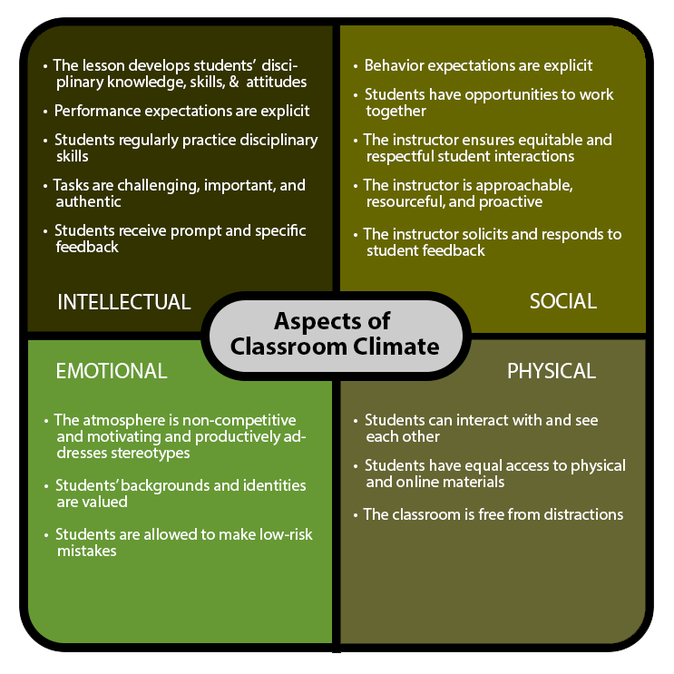

Each classroom must exhibit:

* Posted procedures for everyday classroom occurrences (answering questions, collection of homework/classwork, jobs chart (examples can include a paper manager, teacher’s assistant, office assistant, line leader (in case of the younger students).
* Posted rules, rewards and consequences. These MUST be developed with students. (Signature sheet for students in grades 3-7 noting that students have collaborated on the creation of the rules etc. must be displayed as well).
* Posted daily learning target/learning objectives (relevant to the current learning). This should be displayed prominently and referred to throughout classroom instruction.
* Learning stations will take place at individual student’s desks.
* Updated bulletin boards/classroom space that is appealing to the eyes and display exemplars of individual and group work with effective feedback. (Display must include a copy of the task, the rubric used for scoring, the objective and the relevant CCSS, NGSS or NJLS).
* Anchor charts (refrain from store bought material) that are student/teacher created. These charts must be attractive, informative and must reflect the learning that is taking place. Students must be able to use them as references for and models of the expected work. By October 1, the teacher/student created anchor charts should be the primary displays in your classroom.
* Please ensure to use all PBSIS expectation posters in your classroom and review them periodically with your class.
* A district-wide book challenge is organized through reading rewards.com. Teachers in all content areas are encouraged to provide students with opportunities for reading.

**Classroom Management (please see Restorative Justice and SEL)**

* Classroom management deals with establishing procedures for all classroom activities (lining up, turning in homework, retrieving materials, etc.). It is essential to the effective operation of any classroom. Teachers are to establish rules, a system of rewards and consequences and rapport with parents to assist with creating a classroom that is free of incidents that detract from instructional time.
* The teacher handles minor discipline issues. When creating class consequences, ensure students are aware of the various levels of discipline. For example, what happens if there is a first offense, second offense, etc. (refer to the Office Conduct Referral Form)
* Choose a buddy teacher who can assist if a student needs to have a few minutes to gather his/her composure. Create a reflection sheet for students, so that they can write about the incident, their feelings and how the situation could be handled differently.
* Discipline is not a group matter. Do not punish all for the misbehavior of a few. Consequences should be appropriate to the infraction and should support the school’s philosophy that students should learn from their mistakes. (Responsive Classroom)
* Board Policy #3217-USE OF CORPORAL PUNISHMENT  
  The Board of Education cannot condone an employee's resort to force or fear in the treatment of pupils, even those pupils whose conduct appears to be open defiance of authority.  Each pupil is protected by law from bodily harm and offensive bodily touching. Teaching staff members shall not use physical force or the threat of physical force to maintain discipline. (see full policy 8441 and N.J.S.A.18A:6-1; 18A:37-1)
* Parent communication is critical to any classroom management system. It should be and informative. All parent contact must be documented in Genesis and in a communication log. Use of digital communication apps are encouraged (class dojo, remind).

**Classroom Webpage**

All staff members are required to develop and maintain a classroom website. Staff webpages will be part of the Academic Walkthroughs. The site should include information about the classroom, curriculum, special events, teacher contact information, events taking place in the classroom, office hours, Google Classroom codes, links and times to meets, and parent resources. All homework and assignments must be posted in Google Classroom. Posting of student pictures or any such information requires teachers to follow the district’s AUP (Acceptable Use Policy). If there is any teacher who needs support in this area, please let us know so that you can receive support.

All staff webpages must display Google Classroom codes, teacher office hours, and an email for parent contact. In Phases 1-4 updating of the classroom webpage is vital to assist the students with instruction and to continue clear communication with parents.

**Common Planning Time/ Small Learning Communities**

During this scheduled time, it is the expectation that teachers come on time, prepared to discuss student work, analyze data, plan lessons, and discuss relevant information that is critical to effective teaching and learning.

Guidelines for the operation of these meetings:

* Common Planning Time and Planning Time have been secured to provide quality time for staff to plan collaboratively and at times receive professional development from Administrators, Supervisors or peers. Please ensure that you do not leave the premises at this time (unless in case of an emergency and with the approval of the principal).
* Choose a team leader and communicate the name to the principal no later than September 11, 2020.
* Determine the norms of operation for the group (such as come prepared with materials needed, be on time for meetings, everyone has a voice, etc.).
* **Cell phones must not be used during the meetings. In case of an emergency step outside of the meeting.**
* Determine roles for the meetings (time keeper, recorder, etc.) and communicate to the principal no later than September 11, 2020.
* An agenda is prepared for every meeting. The team leader/SLC coordinator is responsible for this. Administrative input will be added once the agenda is submitted. Agenda items must be submitted at least two days before the scheduled meeting so that team leader/SLC coordinator has sufficient time to prepare. Members should be informed at least two days in advance about the materials that they must bring to the meeting.
* Teachers must sign in the time of their arrival.
* Minutes are recorded and shared to all members of the team and the administrative staff. This is due two days after the meeting is held.
* Teams must utilize a platform created by the administrative team to share information.
* Administrators will be present in meetings to provide PD and/or provide support during teacher led sessions.
* All staff members must have their cameras on during any virtual meetings.

**Computer Use**

Teachers are to avoid inappropriate websites or websites that have no educational relevance or value.  Under no circumstances are students to have access to a teacher’s computer.  Disciplinary action will be taken against the person who is logged in to the offending computer, not necessarily the person who is misusing the computer.  It is a good idea to log out of your computer if leaving it unattended for an extended period. Teachers are encouraged to sign-up for and utilize the two computer labs in both buildings.

**Copy Machines**

Paper and toner are expensive, please consider all copying needs carefully.  No student is to be sent to make copies.  The district has a print shop at the high school for large print jobs. Copies are to be made before your classes. At no time should teachers leave classes unattended or send paraprofessionals to make copies during instructional time. Teachers should not share log-in pins with anyone.

Report any problems with the copier (jams, need for ink and/or staples) to the main office immediately.

**Custodial Responsibilities**

If there is a concern about the cleanliness of your classroom, bathrooms, hallways, stairs, etc., please notify the secretary, immediately. Although the custodians are responsible for keeping our building clean, we all must monitor and address any situation that impacts their ability to do their jobs. Teachers will be asked periodically to complete a survey/ rubric to help us monitor the cleanliness of our surroundings.

**Data Protocol**

The data protocol is a six-step process used by the school, grade-level teams and individual staff members to collect and analyze data and make decisions regarding instructional pedagogy, practices and strategies.

Step 6: Monitor and evaluate the results

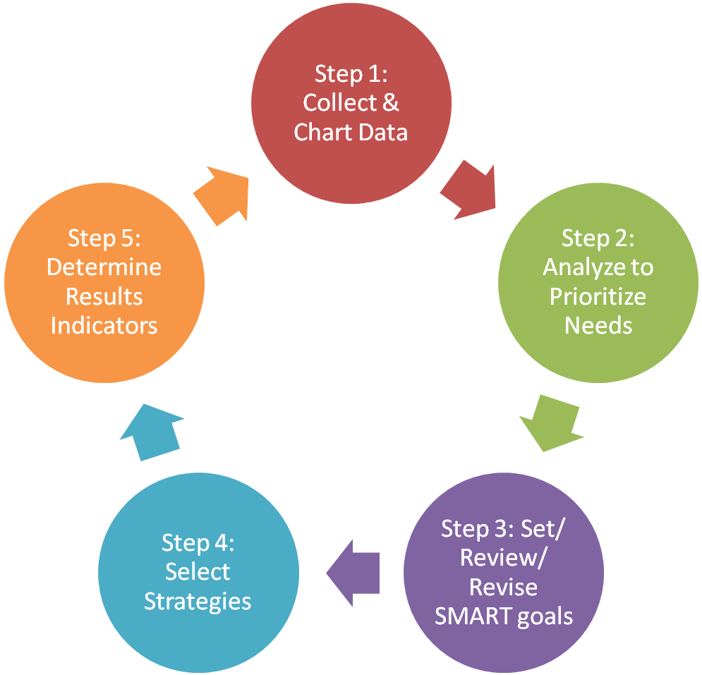

Our Data Process will consist of:

* Grade level teams and individual staff members are responsible for data collection, analysis, development/implementation/monitoring of action plans, reassessment and each grade level or SLC or subject area)
* Vertical level teams (consists of grade level team leaders or content level leaders- report out on data activities at each level)

Teachers/staff will receive training on the data protocol for the 2020-2021 school year, as we continue on our journey to becoming a data-driven community.

**Discipline Referrals (Policy 5560 & 5600)**

Staff must alert the respective administrator only after the teacher/staff member has exhausted ALL class level attempts to resolve the issue or in a situation that is egregious in manner. An OCR (Office Conduct Referral) must be emailed to the respective administrator. In case the teacher is unable to immediately complete the form, please do so as soon as possible. In this case send a note. As soon as your situation permits, a Genesis record must be submitted in notes, including the date and time of the incident and an account of the incident, including teacher actions.

When the administrator acts on the referral, it will be documented in Genesis.

OCR guidelines:

* All OCRs will be completed on the computer.
* Submit an electronic copy of the OCR to the respective secretary and administrator.
* It is critical to complete all components of the form (name, date, time location, etc.).
  + This will allow us to map out behaviors and deploy certain interventions designed to help you.
* Please adhere to the steps required by the form.
  + If you are dealing with minor behavior problems, annotate the 1st, 2nd, and 3rd offense. The administrator will only accept an OCR after the 3rd offense or major infraction.
  + Record actions taken and the intervention dates when you record incident in Genesis.
  + In Genesis, use the Notes tab rather than the Conduct tab. The Conduct tab in Genesis does not trigger any actions from administrators.
* Major infractions will be addressed immediately!
  + Security will remove and escort to the respective administrator.
  + The OCR has to be submitted as soon as possible.
* Feedback to your reporting, OCR, will be found in the conduct tab in Genesis.

Please refer to the Code of Conduct for guidelines in dealing with discipline issues in your classroom.

Students are not to be sent to the principal or assistant principals’ office during the month of September unless the incident is egregious. This is the time to establish yourself as the manager of appropriate behavior for your students.

**Distribution of Flyers and all other Correspondence**

**The principal must approve** printed material before it is distributed to students. Before sending to the office for approval, have three colleagues check for grammar, spelling, mechanics, appropriateness, etc. Make corrections suggested and turn in to the main office personnel. Please collect approved copy from the campus on which your classroom is located. Approved items for Thursday folders must be submitted to the Main Office by end of school Tuesday of the week of distribution.

Correspondence should be sent home in the communication folders (Thursday envelopes) every Thursday. An exception is the first week of school when information will be sent home to be returned on the next day. This necessitates timely submission of information that is targeted to go home with students.

**Dismissal of Students**

**All students are to be accompanied by their teacher out of the building at dismissal**. Please refer to the Standard Operating Procedures included in your opening day packets. Teachers who are scheduled for Hall Duty at the time of dismissal are required to be at their post to ensure a safe dismissal of students. Students should be encouraged to disperse quickly and safely, while adhering to the social distancing guidelines.

Students must bring a note for an early dismissal. **Students are not to be sent to the main office to wait**. They will be called to the main office when the parent arrives.

Walkers may be dismissed. Do not leave students outside. Escort them back into the building, contact the parent and notify an administrator and security if the child is not picked up within a reasonable time.

**Phases 3 & 4 dismissal times and locations**

**Grade 3**

* Students are dismissed at 3:20 p.m. in front of the school.
* Use the gymnasium doors (west stairwell)

**Grade 4**

* Students are dismissed at 12:30 p.m. in front of the school.
* Front Door (east stairwell)

**Grade 5**

* Students are dismissed at 3:20 p.m. using the West Stairs exit to Main Street (facing the Post Office).
* YMCA (west stairwell)

**Grade 6**

* Students are dismissed at 3:20 p.m. in front of the school.
* East Stairwell through gymnasium doors.

**Grade 7**

* Students are dismissed at 3:20 p.m. using the North Stairs exit (facing playground).
* Side of school (via north stairwell)

Parents are not permitted to enter the building**.**

**All teachers are to escort their last period class to the assigned exit doors** of the school building-practicing social distancing or wearing face coverings as mandated. Instruction continues until that time. Students should not be sitting around and losing valuable instructional time waiting to be dismissed. During Phases 3 and 4, the students will be dismissed as follows:

**Developmental Report Cards (DRs)**

DRs contain confidential information and are kept locked up in the office. If taking DRs out of the office, they must be signed out and back in with the office secretary. DRs may only be worked on in the school building in a private setting.

**Dress Down Days (Policy 3216)**

During these announced events, staff is still expected to dress in a professional manner and adhere to the guideline given in policy #3216. Special instructions will be given when these are announced.

During field trips, staff is permitted to wear jeans and sneakers (if field trips outside of the district are approved).

**Employee Dress Code (Policy 3216)**

Employees of the Orange Township School District shall be neatly attired and groomed during school hours. All employees must follow the District’s dress code. **Employees who are inappropriately dressed will be asked to change into clothing that meets the standards set by the Orange Public Schools.**

Policy 3216 (a copy is included in your opening day packet) stipulates that:

Females are permitted to wear shirts, slacks, blouses or sweaters, dresses or slack suits.

Males are permitted to wear a dress shirt or similarly tailored sports shirts. Dress or Sports jackets with ties are strongly encouraged, but not required. Turtleneck shirts and sweaters are permitted. All shirts worn by male teachers must have a collar.

Please note that the following are **not acceptable** during school hours:

* Jeans
* Torn or dirty clothing
* See-through or low-cut blouses
* Excessively tight-fitting clothing
* Jogging suits (dance and P.E. only)
* Any dress or grooming which would attract undue attention, create disruption or would be potentially unsanitary or dangerous
* Beach wear (flip flops, beach jackets, swimwear, etc.)
* Shorts: “shorts” shall mean the Bermudas, cut-offs, hot pants, culottes that look like shorts, athletic shorts or swimsuits.
* Sneakers
* Dresses and skirts shall be knee length or longer.
* Hats in the classroom. Religious head coverings, however, are permitted.
* No leggings, pants made of spandex material, or low-rider pants

**While operating remotely, the expectation is that staff maintain a professional dress code when conducting synchronous instruction or holding meetings.**

Special Dress Code Rules

Physical Education/ Dance

Physical Education and health teachers may wear clothing appropriate to their subject area. This would include athletic jackets, T-shirts, pullover shirts, pants or slacks, jogging or warm-up suits, and appropriate footwear.

Other Classes

Other protective clothing such as smocks, lab coats, and aprons may be worn as needed by teachers in laboratory science or art. Eye protection shall be worn as otherwise required.

Other employees

Employees involved in transportation, maintenance, and custodial staff and cafeteria workers shall wear appropriate clothing to accommodate their working situations as determined by contractual provision or their supervisor.

Please provide medical documentation when making requests to wear items that are on the prohibited list.

**The dress code will be enforced for all staff.**

**Errands (Policy 3280)**

Students are not permitted to run errands for the teacher that are contrary to school and district policy. Examples of this include leaving the building to retrieve items from cars, carrying hot liquids (coffee, etc.), utilizing the microwave ovens, making copies, picking up food deliveries, picking up delivery boxes, and delivering inappropriate messages to other staff members or members of the administrative team.

**Evening Events**

If it is our goal here at Rosa Parks Community School to build relationships with our parents and the wider community, it is critical that we support school events. Some of these may occur in the evening hours. Students and your colleagues are validated when you attend these events. As we work on encouraging parents to attend the PTO meetings, having teachers present at the meetings will go a long way in demonstrating our commitment to this home school connection.

All certificated staff members are required to participate actively in a **minimum** of five evening/ night functions. Back to school night, parent/teacher conferences, and either the winter or spring concerts are RPCS required events. Sign in sheets will be made available to document your attendance at every event.

You are welcome to attend as many events as you can. That would be greatly appreciated by our students, their parents, and the leadership of the PTO, your colleagues and certainly the Administrative Team.

**Field Trips**

**All field trips will be virtual until further notice.**

The teachers organizing the trip are responsible for:

* Completing the Field Trip Request in My Learning Plan
* Arranging for one chaperone for every ten children
* The grade level leader/SLC coordinator MUST notify the lunch staff two weeks prior by submitting a Lunch Request Forms.
* Notify the nurse two weeks before the trip of any medication needs
* Making all admission arrangements, complete with requisitions
* Bringing the First-Aid kit on the trip
* Offering parents opportunities to attend the trip for behavioral/safety issues with particular students
* Ensuring all students are in uniform or agreed-upon appropriate attire
* Arranging alternate accommodations for students who are unable to attend the trip and leaving ample work for completion during the school day

Students are not to be excluded from trips that are noted as integral to their course work. Instead, ask a parent to accompany the student on the trip.

**Films/Movies**

All films or movies are to be previewed by the teacher.  Movies/films should reflect the curriculum of the district.  Only movies with “G” or “PG” ratings should be shown.  If you are showing a rewarding film or one rated PG 13, office and parents need to be notified.  Parents should be notified that you will be showing the movie, and the name of the movie.  This notification should be done early enough so that parents have sufficient time to opt out of letting their child view the film.

**First Days of School**

It is important to set the tone for the school year in the first days of school. Be ready to share your expectations with your students. Establish procedures, rules, a system of rewards /consequences, and convey to your students the importance of compliance with the agreed upon operating protocols.

Select classroom managers (office, teacher’s assistant, paper, line leaders, cafeteria monitors, etc.) that will assist with the day to day running of the classroom.

Please be guided by the following as we work through the first days of school:

* Admit only students who are on your class lists to your class. **Notify the School Counselors of students who are no shows.**
* Before admitting a new student to your class, ensure you receive the admission documentation from the office.
* Do not switch students with other teachers. They all have schedules that have been created and logged into Genesis. Changes will be made by the School Counselors and communicated to you in writing.
* Homeroom attendance must be entered into Genesis by 8:30 each day.
* Ensure that students return all required forms/information promptly. Submit all forms and classlist when you have received 100 percent of the forms. Contact parents who have not returned the forms to ensure all forms are returned by the due dates. Report the names of those who have not returned their information to the main office personnel by 9:00 on Friday, September 13, 2019. Phone calls will be made to follow-up.
* Report any problems with student schedules and class placements to Mrs. Murphy or Mrs. Lawal via email immediately.

**Fund Raising /Monetary Transactions**

All money received by clubs, classes, or any organization under the direction of the school is classified as school money according to law and must be accounted for within the school bookkeeping system.  Money is not to be left in your room during the day or night, but instead turned in to the office as soon as possible in a sealed and labeled envelope.

Under no circumstances will teachers or staff be allowed to conduct fund raising activities without prior approval from the school principal.

Please adhere to the following:

When money is collected from students, please complete on the collection form and return to the main office personnel **no later than 10 am** of the collection day. Your total with your signature must be included on the sheet. Please use your class collection envelope to send your money to the office. NO MONEY IS TO REMAIN IN YOUR CLASSROOM. If the protocol is not followed, you will be responsible for the misplaced/lost monies.

**Genesis and Email Issues**

Any issues with Genesis or emails, please request the form from the Main Office. Return it to the respective secretary via hard copy or email.

**Grading and Retention Guidelines (Policy 2624)**

PLEASE REFER TO THE REVISED DISTRICT GRADING AND RETENTION POLICY.

Student Responsibility Factors (used as a measurement for Citizenship Honor Roll)

* Non-Academic Factors Effort, Attitude, and Motivation are separate grades.
* Effort: participation, work completion, tenacity, resilience, willingness, meets requirements on assignments, and seeks support when needed.
* Behavior: working in groups, teamwork, coming prepared, meeting classroom and syllabus expectations, and following rules and directives.

**Gradebook/Genesis**

Your grading system should be explained to students and justified when necessary to students and parents.  It is important to remember from this point forward; student grades can be accessed by parents via the Parent Portal in Genesis.  Please make sure that your grades are kept current.  Don’t wait until the week before report cards to grade assignments and enter them in the Gradebook. The administrative team on a weekly basis will monitor Genesis. Please note, Gradebook must be updated periodically throughout the marking periods since the new initiative is for parents to access Parent Portal.

Frequency of Grade Reporting

* Report cards are disseminated quarterly (4 times per year) every nine weeks.
* Progress reports are disseminated the fourth week in each marking period. (Unless teacher deems it necessary to send an interim)
* If a student is exhibiting unsatisfactory performance or is experiencing a change in performance, parents/guardians must be notified by the teacher promptly before the distribution of the progress report or report card to discuss an academic corrective action to improve student achievement.
* Please adhere to district calendar/ signed report cards are due back to the reporting school no later than five days after receipt of the report card.

Grading Weights

PLEASE REFER TO THE UPDATED GRADING AND RETENTION HANDBOOK.

Explanation of Academic Grades (Grades 3-7)

A (Exceeds the Standard) ….. 90-100

B (Meets the Standard)…..80-89

C (Marginally Meets the Standard)…..70-79

D (Below Standard)…..65-69

F (Unsatisfactory Performance 50-64)

Teachers are expected to communicate frequently with parents regarding student performance. Parents should not be surprised at progress report and report card times. Teachers would be expected to keep a log of communication with parents. It should also be entered into Genesis under “notes”.

District guidelines mandate students who score 72% and below a parent teacher conference and an

the action plan must be completed.

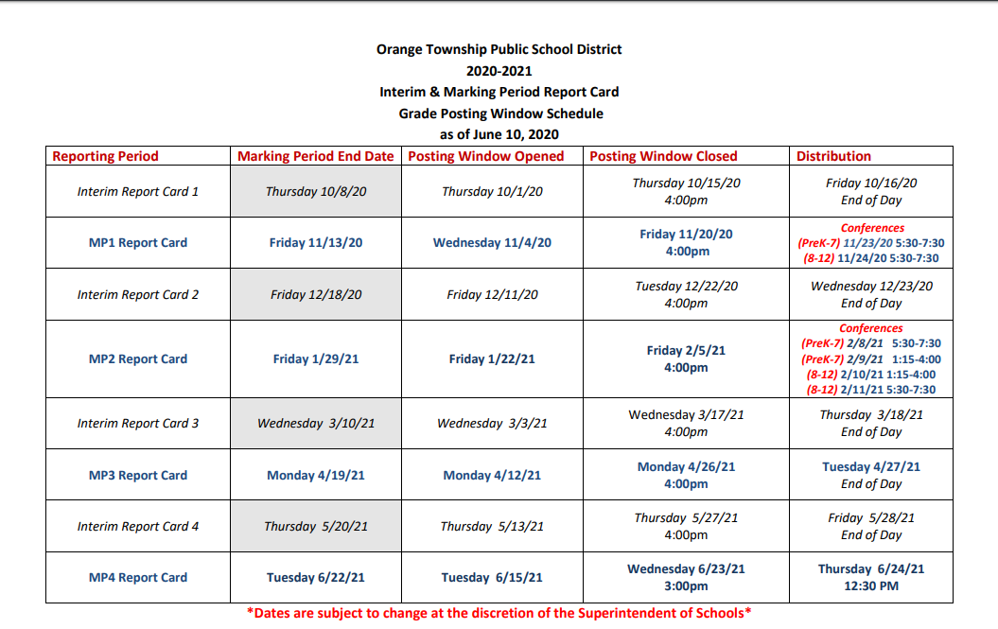

**Harassment, Intimidation, and Bullying**

All Staff members are expected to follow all State and District guideline regarding the HIB policy, procedures and process when reporting suspected/alleged incidents. The District policy can be located on the District website ([www.orange.k12.nj.us](http://www.orange.k12.nj.us))

**Homework**

Teachers are to assign homework to students for the purpose of reinforcing skills taught in class.

You are required to follow District guidelines on homework assignment times.

Daily minimum requirement of meaningful homework:

Grade 3 60 minutes

Grades 4-7 70-75 minutes

**Interventions (Policy 2414)**Students at 72% or lower in any academic content area must have a parent teacher conference. (Notification form can be found in the Grading and Retention Guidelines Handbook))

An Intervention Plan and Timeline must be put into place (Form found on page 54-55)

Possible Interventions:

* Student taught at the 2 or 3 level of the Instructional Scale for differentiation
* Additional Instructional Time (Teachers may offer before or after school tutoring)
* In class supplemental or small group instruction: Teacher differentiate instruction to meet student’s needs (see Genesis Lesson Plan)
* Extended day or extended school year (i.e. After school, Winter Program, Spring Program, Saturday Academy)
* Peer tutoring: students avail themselves to assist their peers
* Morning Program
* Technology based Programs (i.e. Khan Academy, Brain Pop, Spelling City, Rosetta Stone, SOLO, Discovery, Readorium and ST Math, etc…)
* iRead-Grades K-2 (Reading Program)
* System 44 Grades 3-7 (Reading Program)
* iReady – Grades K-7 (Reading and Math Program)
* Mentoring Programs; Peer Mentoring /Advocacy Periods
* 504 Plan
* IEP
* Homework
* ESL/ LEP Classes
* Adaptations: this is especially for Special Education
* Homework (Differentiated homework designed for students who need extra support)
* Parent/ Student Contracts
* I&RS

***This is not an exhausted list.

***Reminder: Intervention Form can be found in the main office and/or online.

**Intervention & Referral Services (I&RS)**

The purpose of an Intervention and Referral Services Program are:

* To identify learning, behavior, and health difficulties of students
* To collect thorough information on the identified learning, behavior, and health difficulties
* To develop and implement action plans which provide for appropriate school or community interventions and referrals to school and community resources
* To work with teachers and to assist in achieving the desired outcomes

Members of I &RS Committee:

* Principal or Designee
* General Education Teacher
* School Counselor
* School Social Worker
* School Nurse
* Child Study Team Members

Process

Phase 1:

Submit Request for Assistance

Teacher, counselor, administrator, parent, or SLC completes referral.

* Referral form should be thoroughly completed including names and dates in the intervention section. This must include the Request for Assistance Form, Student Web, and Pre-Referral checklist. Also, the description of the problem should be measurable and observable, not subjective.
* Failure to not complete the steps in the intervention section and provide an adequate description of the problem will result in a return of the referral.
* Referral must be submitted directly to the I&RS chairperson—do not place in counselor’s mailbox or hand deliver referral.

Phase 2:

Information Collection

The chairperson reviews the referral for consideration.

* Incomplete forms will be returned to the initiator for revisions.

The chairperson assigns a case manager from the I&RS to the referred student.

* The assignment is based on a predetermined revolving basis.
* All I&RS members are case managers.

The case manager sends the nurse the Health Report.

* The form should be completed by the nurse and returned to the case manager within five school days.

The case manager reviews the student’s Developmental Record (DR) and Genesis data.

* Test scores and grades are prepared by the case manager for presentation at the team meeting, including assessment scores, grades, discipline records, and attendance records.

The case manager sends all teachers the I&RS Teacher Collection Form.

Teachers should complete the checklist and return it to the case manager within five school days. -Samples of student work, Parent Conference notes, CPT/SLC notes, evidence of the intervention strategies implemented and data to support the outcomes.

The case manager reviews all the data and prepares it for presentation at the committee meeting.

Phase 3:

Parent/Guardian Notification

The case manager contacts the parent/guardian(s) of the referred student.

* Describe the nature of the referral and ask for the parent/guardian’s input.
* Invite them to the I&RS meeting.
* The parents do not have to be present at the meeting, but it is recommended.

The case manager’s role with the student:

* The case manager observes the student in the class of the referring teacher.
* Additionally, the case manager should meet with the student and interview him/her.
* There is a self-assessment in the I&RS packet for the students to complete.

The case manager contacts the chairperson to have the student placed on the I&RS agenda.

* Meeting should take place within two weeks of receiving the initial referral.
* Teachers should be given at least one weeks’ notice of the meeting.

Phase 4:

Problem Solve

I&RS Team meet.

* The team will meet to develop an effective plan focusing on 2 to 3 strategies, based on the information provided by the case manager.
* The parent and student may be present.

Phase 5:

Develop I&RS Action Plan

The case manager prepares Action Plan.

* The case manager will write the plan and present it to the team members for their signature and approval.
* The case manager will submit the student’s completed file to the appropriate administrator before distributing action plans.
* Action plans will be signed and dated by the chairperson.
* After the chairperson reviews the file, teachers will be given a copy of the Student Action Plan within five school days of the initial meeting.
* The action plan’s goals must be attainable and incremental. A student who has never turned in homework should not be expected to have 100% completion in one week.
* Action plans should not contain more than 3-4 actions.

Phase 6:

Support, Evaluate and Continue the Process

The case manager schedules a follow-up meeting.

* A follow-up meeting will be scheduled for 6-8 weeks after the initial meeting to monitor the student’s progress.
* Revisions should be made to the plan.

Meeting Schedule:

Held once per week on Wednesday or Thursday when the Child Study Team is available to meet with the general education teachers.

**Lesson Plans**

Lesson plans should be collaborative. Although grade level teams plan together, the expectation is that each teacher uses that model to create authentic plans reflecting the needs of his/her students. It is not one size fits all. Plans are written on a weekly basis. They are to be submitted in Lesson Planner in Genesis **no later than 5 PM Fridays**. If for any reason you need to address an issue with your lesson plans, please do so promptly. In the case that you are absent on the day lesson plans are due, they are due by 5:00 pm on the day of your return to work. Please access your plans for feedback and respond by the comments made. Administrators will review your plans weekly and make comments in a timely manner-no later than 24 hours before the start of the next school day. A schedule of submission dates is included in your opening day packets.

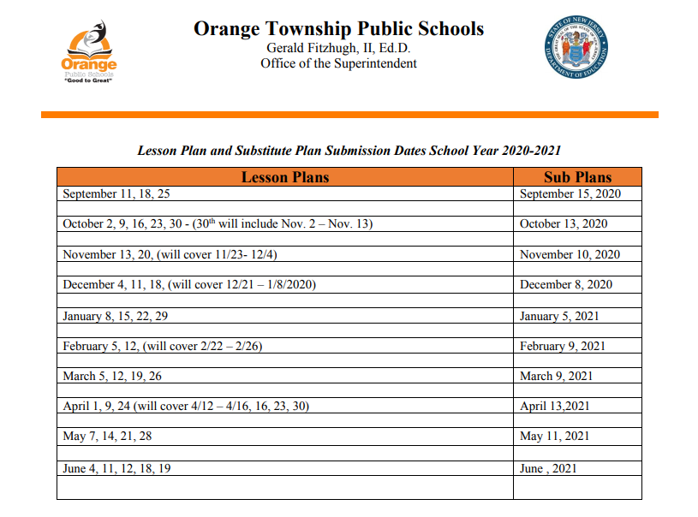

**Lesson Plan Format**

Your plan should include all the components as directed by your department and administrators. You will receive guidelines during the professional development session the first week of school.

**Lockers \*\*\***

Teachers must determine a procedure for going to lockers in the morning and at the end of the day. Students should not be unsupervised in the hallway. By the end of the first week of school, please post a copy of the agreed upon procedure near the lockers to ensure that students are aware of the procedure before going to their lockers. Please monitor that all students are adhering to the procedure.

We require a PE uniform. For Physical Education, students must come to school dressed in their P.E. uniform. They will not be allowed to change for Physical Education. For Dance, students must wear appropriate dance attire under their uniforms. They are not allowed to bring and change into dance uniforms.

Please monitor the following locker expectations: Students are to use quiet / inside voice, use their assigned locker, use their locker at designated times, and walk directly to their destination. Teachers must in the hallway during switching of classes and locker usage.

During Phases 3 & 4, lockers will be limited or not in use. Administration will inform staff before the roll out of the Phases.

**Lunch**

There is a 30-minute lunch for the staff. Eating or drinking (water is the exception) in the hallways and during instructional time is not permitted. Walking around during instructional time with coffee, tea, food is unprofessional and will be noted as such. Be aware that carrying hot beverages in the hallways, classrooms, and other places where students are present can cause injury and is therefore prohibited.

Teacher’s Room – This area is for **teachers** and **staff** only. Do not send students on errands to this location. Staff should not congregate in this area unless you are able to adhere to the social distancing guidelines or the mask mandate as outlined in the OPS School Reopening Guidelines.

**Master Calendar**

Teachers should clear all speakers, trips, and meetings with the principal before scheduling. This is to avoid scheduling errors and duplication of times.

**Morning Procedures/Routines**

Teachers are to establish morning routines for emptying backpacks, hanging up coats and going to lockers quickly and quietly. During phases 1 and 2 instruction begins promptly at 8:45 a.m. During phases 3 and 4 please follow the schedule as outlined.

All teachers and students are expected to participate in the Pledge of Allegiance and the School Creed. Please also ensure that there is quiet during the morning announcements. Please see the Standard Operating Procedures for a thorough, detailed description of the morning procedures and routines. A copy is included in your opening day packet.

**Parking**

Parking is available on a first come, first serve basis. The garage at the RPCS, street parking, limited parking at the church across the street, and in the YMCA parking lot on High Street (be sure to have your staff decal visible on your dashboard) are available.

* Parking spaces in the front of the RPCS building are reserved for visitors to the building and administrators. Employees are not permitted to utilize these spaces. Additionally, parking on the playground is prohibited.
* If handicapped parking is required, please make arrangement with the principal who will notify the Security Staff.
* **Secure parking prior to signing in.**
* **No announcement will be made to correct parking situations.**

E**veryone must be mindful with social distancing guidelines when entering through the garage.**

**Phone Usage Policy (Policy 3321)**

Personal calls during work hours are prohibited. The office will not accept personal calls and relay messages unless it is in an emergency situation.

Cell phones are also not permitted during instructional time, CPT, staff meetings or professional development times. CELL PHONES ARE NOT PERMITTED DURING YOUR SCHEDULED DUTY PERIOD. This applies to ALL staff. Please refer to Board Policy # 3321 to guide your actions regarding the use of cellphones.

**\*\*\*Positive Behavior Model of Discipline**

Rosa Parks Community School is part of PBSIS (Positive Behavior Support In Schools). We have partnered with the New Jersey Positive Behavior Support in Schools (NJ PBSIS) initiative to design and implement school-wide interventions that will focus on promoting positive student behavior, improve our sense of community, and provide supports for students who need a little extra help.

Through the NJ PBSIS initiative, we are learning about how to enhance our school’s climate and atmosphere. In particular, we are focusing on how to:

1. Clearly, define for students what is expected of them.

2. Be consistent across staff in how we talk to students about those expectations.

3. Improve our procedures and routines so the school day runs smoothly.

4. Provide lots of encouragement and social praise when students display the school expectations.

5. Make students feel welcomed and valued.

6. Encourage positive interactions between students and between students and staff.

7. Provide students with help and support to overcome challenges and difficulties academically, socially, and behaviorally.

**Professional Conduct**

* Sharing confidential student information with others is unethical and illegal. It should not be a practice.
* Be respectful of the workplace of the administrators/secretarial staff in the main office. Lingering or socializing in the main office is not allowed. Request permission to enter the office area.
* Teachers should not visit colleagues during instructional time.
* Instructional time during Encores is as important as during core classes. Please ensure that respect is afforded the teachers and students as they are involved in instruction and learning.
* Adhere to all deadlines.
* Be respectful at all school/district meetings and professional development. These are not occasions for grading papers, reading/ responding to emails and engaging in conversation that is not related to the material being discussed.

**Purchase Orders**

Please ensure that you place all orders with the main office personnel. If your purchases are not aligned to our instructional goals, they will be returned to you. Please return all packing slips to the main office personnel with received items clearly highlighted. This should be done no later than one week after receipt of your order. **Do not use personal funds to purchase items. You must get approval, or you will not be reimbursed.**

**Recess**

Recess is suspended until further notice.

**Restorative Justice**

Restorative justice (RJ) is a powerful approach to discipline that focuses on repairing harm through inclusive processes that engage all stakeholders. Implemented well, RJ shifts the focus of discipline from punishment to learning and from the individual to the community. We will train staff to utilize this as our preferred method of addressing disciplinary issues.

**Retention Guidelines (Policy 5410)**

ELEMENTARY/MIDDLE SCHOOL GRADES (1-7)

1. Re-teaching and Re-testing procedures have been established
2. Parental Contact (dates) logs maintained in Genesis
3. Student Conferences (dates)
4. Intervention plans have been established (72% and below conferences, plans/contracts, and timelines have been established)
5. Students should be referred to I&RS
6. Monthly letters generated from Genesis are sent to parents
7. Parents of students in jeopardy of being retained should have an initial notification in February
8. The last week of May a formal letter must be sent and a conference held
9. Parents may file appeals; however, all appeals are finalized by the school principal.
10. An educational plan must be developed for all students retained

*No student will be approved for retention without the required documentation.

IMPORTANT FACTS

* There will be no Kindergarten retentions
* There can only be one (1) retention for children grades 1-4.
* There can only be one (1) retention grades 5-7.
* Students who have been retained once and are still experiencing academic difficulty should be referred to Intervention and Referral Services (I & RS).

**Regular Fire and Safety Drills**

1. Fire Drill*
2. Lockdown Drill – Internal Threat
3. Shelter In Place – External Threat
4. Evacuation Drill*
   1. Leave the school
   2. Move to Shelter
5. Bomb Threat Drill
6. Tabletop Drill

*All employees/persons in the building must exit the building during these drills

Fire Drill

1. Students will line up quickly and remain quiet in line during the entire drill.
2. Teachers must bring Class Roster(s) from Genesis, as well as green and red sheets to signify if they have their entire class (hold up green), or hold up red if they are either missing one of their present students or have an additional student that got misplaced from their own class.
3. Turn off the lights. Close the classroom door.
4. Exit the building using your assigned staircase and exit route.
5. Return to the classroom only upon an “All-Clear” signal.
6. All employees/persons in the building must exit the building during fire drills.

Evacuation Procedures

* Evacuation of the building will be triggered by the sound of the alarm.

– Shelter In Place- External Threat Procedure

* An “External Lockdown” announcement will be made over the PA system.

This is ____________________, this is a lockdown. This is _________________, this is a lockdown. This is ______________________, this is a lockdown.

* Remain calm.
* Lock classroom doors. Teachers must leave their classroom key with a visiting Encore/special teacher
* Continue to teach.
* No students may enter/exit the classroom.
* Any students in the hallways, bathrooms or stairwells at the time of a “Lockdown” shall report to the designated “Safe Rooms.” Rosa Parks Campus
  + 1st floor ----- Nurse’s Office
  + 2nd floor ----- Room 209
  + 3rd floor ----- Rooms 310 and 316
  + 4th floor ----- Room 410 and 415
* Any students in the hallways, bathrooms or stairwells at the time of a “Lockdown” shall report to the designated “Safe Rooms.” Central Campus
  + 1st floor ----- Rooms CS 4 and CS 8
  + 2nd floor ----- Nurses Office and CS 18
  + Basement ----- Community Room and B-1
* Safe rooms are designated with an “S” on the wall next to the doors. Make sure students are informed of the safe rooms for each floor and this procedure.
* Safe rooms will be left unlocked for 2 minutes longer for students in the bathrooms, hallways or stairwells to arrive.
* Custodians will lock the door to the main office and all gym doors.
* An “All-Clear” will be announced three times at the end of the drill.

This is ________________, All Clear. This is _______________, All Clear. This is ____________, All Clear.

Lockdown – Internal Threat Procedures

Code “Lockdown Internal.”

* An “Internal Lockdown” announcement will be made over the PA system.
* Remain calm.
* Lock classroom door. Teachers must leave their key with a visiting Encore/Special Teacher
* Shut off lights and any electronic device(s) that makes a sound.
* Have students sit in complete silence on the floor against the wall that is not visible from the room windows and door window. Place cover over door window if possible.
* Visually take attendance.
* No students may enter/exit the classroom.
* Any students in the hallways, bathrooms or stairwells at the time of a “Lockdown” shall report to the designated “Safe Rooms.” ( Rosa Parks Campus)
  + 1st floor ----- Nurse’s Office
  + 2nd floor ----- Room 209
  + 3rd floor ----- Rooms 310 and 316
  + 4th floor ----- Room 410 and 415
* Any students in the hallways, bathrooms or stairwells at the time of a “Lockdown” shall report to the designated “Safe Rooms.” (Central Campus)
  + 1st floor ----- Rooms CS 4 and CS 8
  + 2nd floor ----- Nurses Office and CS 18
  + Basement ----- Community Room and B-1
* Safe rooms are designated with an “S” on the wall next to the doors. Make sure students are made aware of the safe rooms for each floor and this procedure.
* Safe rooms will be left unlocked for 2 minutes longer for students in the bathrooms, hallways or stairwells to arrive.
* Custodians will lock the office, conference room, and all gym doors. Office staff will go into the conference room, keep the door locked and sit on the floor where they cannot be seen from the door or windows. Close the window blinds if you have time to do so.
* Ignore all bells, including the fire alarm. DO NOT come out of your sitting position or exit your classroom unless you have FIRSTHAND knowledge of a fire OR were told to evacuate by either SECURITY OR ADMINISTRATION
* The end of the lockdown will be when a second announcement is made stating, “All is Clear” 3 times.

**Requests for Supplies**

Teachers will be asked to sign for received supplies including copy paper. Each teacher will receive a monthly supply of two reams. If additional supplies are needed, the request must be made by completing the supply request form (found in your opening day packet).

**Safety**

Courts view schools as safe places because students are taught and supervised by licensed teachers. You operate in place of parents for students assigned to your classes or who may be in your presence. Ensure you are vigilant in assisting with protecting students from potentially dangerous conditions or activities at RPCS. We must, at all times, provide proper supervision to ensure that your students are protected from avoidable physical injuries.

**School Communication**

1. Students will be given an envelope, with school information, every Thursday to take home and be returned on Friday morning. Flyers/notices will be uploaded/scanned onto our District School website weekly to offer parents another method of receiving/reviewing information.
2. Check your mailboxes in the main office at least twice a day.
3. Check your e-mail by the end of each day so that you can address any information you are given.
4. Communication with colleagues and administration must be respectful at all times. Refrain from sending e-mails that may give the appearance of impropriety. This is an integral part of your observation.
5. School communication protocol demands that if you need clarification on any matter, you must communicate with the building administrative staff. At no time must e-mails be sent to the Orange Central Office staff without first seeking guidance at the building level. Regardless of the Department, building administrators are your immediate supervisors and are the ones to make decisions regarding your operation at RPCS. We work in concert with staff at the Orange Central Office.
6. You will be held accountable for responding promptly to correspondence and adhering to requested deadlines.
7. The administrative team will be accessible to all staff on a time management matrix: first-urgent and important, second not urgent but important. Feedback will be given promptly. Communicate your need to the office staff and they will notify a member of the administrative team. Please refrain from sending unnecessary emails.
8. In the event of an emergency closing, you will receive a phone call from the District on the phone number you provide to the office. Report changes in your phone number to the main office immediately.
9. Instructional staff must indicate their presence by accessing the principal’s morning message by liking or sending received via email.

**School and Home Communication**

Parents are our most important allies in helping our students achieve. Therefore, staff should always begin the conversation with a positive comment about the student. Communicate with parents frequently. Parents do not like surprise. Notify parents in advance if students are performing poorly are in danger of failing, or are just not working up to potential. Do not wait until Progress or Report Cards come out to address any problem a student is experiencing.

If you have set up a parent meeting and had concerns, ask the Principal/Assistant Principals to attend also.

Teachers must keep a Communication Log in Genesis and a hard copy for examination by the administration to document all communication with parents. It is an integral part of your evaluation. You will be asked to show evidence of parental communication.

All teachers are required to attend the District assigned dates for formal parent conferences.

Teachers are required to send a written notification of the conference to the parent/guardian. Utilize Class Dojo or Remind. Document this information in Genesis. Conferences must be scheduled during the teacher’s preparation period or after students’ dismissal. It is required that these meetings be held virtually. Advise the parent/guardian of the credentials for the meeting. Have the Parent Conference Sheet completed after each meeting and submit a copy to your assigned secretary and administrator. Document the outcome in Genesis. Parent meetings involving administrators will be conducted virtually or in a space that allows the practicing of social distancing and mask mandates once there is a return to the building.

**School nutrition- snacks (policy 8505)**

The Board of Education recognizes child and adolescent obesity has reached epidemic levels in the United States and that poor diet combined with the lack of physical activity negatively impacts on pupils’ health and their ability and motivation to learn. The Board is committed to providing pupils with healthy and nutritious foods; encouraging the consumption of fresh fruits and vegetables, low-fat milk and whole grains; supporting healthy eating through nutrition education; encouraging pupils to select and consume all components of the school meal; and providing pupils with the opportunity to engage in daily physical activity.

The following items may not be served, sold, or given out anywhere on school property at any time before the end of the school day:

1. Foods of minimal nutritional value (FMNV) as defined by U.S. Department of Agriculture regulations;
2. All food and beverage items listing sugar, in any form, as the first ingredient; and
3. All forms of candy. (see full policy 8505 & N.J.A.C. 2:36-1.7(a); 2:36-1.7(b)

**School Property**

* Books are on loan to students and must be returned at the end of the year unless they are consumables.
* Assign and maintain accurate records of student book numbers. (please see the standard operating procedures included in your opening day packet)
* Lost books must be paid for by students to be replaced.
* Students are not allowed to destroy/deface/write on/scratch or put decals on desks, chairs, tables, walls, bulletin boards, etc. Teachers are to report any such incidents.
* Encourage school pride in students about their classrooms, hallways, stairwells and outside grounds to maintain a clean and safe learning environment.

**Student Growth Objectives**

You will receive further information on SGOs as the year progresses.

All teachers will set academic goals for their students at the beginning of each school year. These are Student Growth Objectives (SGOs). All teachers will set SGOs. Those in testing grades and or teaching tested subjects will set 1-2 goals, while teachers in non-tested grades or non-tested subjects will set 2 goals. They are created collaboratively between the teacher and his/her immediate supervisor. The Principal has the final decision.

In setting SGOs teachers should take the following steps:

1. Choose or develop a quality measurement tool that is aligned to applicable standards.
2. Determine students’ starting points based on available data.
3. With supervisor input and approval, set ambitious yet achievable students learning goals.
4. Track progress and refine instruction accordingly.
5. Review results and discuss score with a supervisor.

**Social and Emotional Learning**

**“Social** and **Emotional** **Learning** (SEL) is a process which helps children cultivate essential life skills including awareness of one’s own emotions, fostering respect and care for others, establishing strong relationships, making ethical and responsible decisions, and handling adversity constructively.” (The Wallace Foundation) This year this will be one aspect of how we approach educating our students. Staff will receive professional development on the tenets of SEL.

**Social Networking Sites**

The Orange Board of Education prohibits all electronic communication between staff members and students outside the official school email and telephone services. For this policy, “electronic communication” means a communication transmitted using an electronic device including, but not limited to a telephone, cellular telephone, computer, computer network, personal data assistant, or pager. “Electronic communication” include, but are not limited to, e-mails, text messages, instant messages, and communications made using the Internet website, including social media and social networking websites (Facebook, Instagram, etc.).

Please see Orange Board of Education Policies: 4283 Support Staff Members and 3283 Teaching Staff members.

**Staff Meetings, Professional Development and In-Service Opportunities**

Faculty Meetings, Professional Development, and In-Service opportunities are held throughout the school year. It is the expectation that all staff attends and actively participates in their assigned sessions. You must also complete the Evaluation on Frontline to get credit for your attendance. Teachers must not grade papers, indulge in conversation not relevant to the session, use cell phones or other electronic devices (unless for note taking) during these sessions. Staff must attend the sessions for the duration of the assigned period.

**Staff Observations and Evaluation**

These will be conducted throughout the school year. School level administrators, as well as District Level Supervisors and Administrators, will conduct staff observations. They will be both formal and informal, and the conference will follow each occurrence. If you are absent on the day of a scheduled observation, the observation will occur on the day of your return. If for any reason other than absence the observation does not take place a new date will be assigned.

Teachers are to take this process seriously and understand that it is an integral part of your continued employment as a teacher.

**Stipend Sheets**

Stipend Sheets are to be submitted based on the timelines for submission to the business office; late stipend will not be accepted. Please submit all Time Sheets to the main office personnel. Staff members are not to submit sheets directly to the Board unless they are advised to do so by an Administrator. Time Sheets must be submitted to the Business Office for the period outlined by the Business Office (the schedule is included on your opening day packets).

All persons will be accountable for producing original sign in sheets, dated agendas (clubs, other after school activities) clearly outlining what is done during the time for which the stipend is being applied.

**All stipend sheets must be complete with the date, name, position, budget code number, board approval date, the number of hours worked, the total amount due each day, the final total, and signatures as required on the form. Incomplete or incorrect forms will be returned.**

**Student Attendance**

Please review the Standard Operating Procedures for guidance on attendance. Teachers with a homeroom class must enter attendance into Genesis no later than 8:30 AM. Students, who are not present and in class by 8:30, are considered tardy and require a late pass from the main office. Genesis defaults to present. If attendance is not taken each day, the student is marked present. Students who do not present a late pass must be sent back to receive one from the main office. **All teachers must take class attendance each day**. **Attendance must be taken during virtual instruction and documented in Genesis for each class you instruct.**

Please discuss the importance of attending school daily and on time with your students.

You need to report excessive student absenteeism to the office and make a referral to the Attendance Officer. A referral is required if a student is absent for 3 or more days.

Students are required to bring a note after an absence. Please note the absence and reason in Genesis and keep all non-medical notes in the classroom. Medical notes should be forwarded to the School Nurse.

NOTE: When a parent calls to inform the school that a student will be absent/tardy, please communicate this information with the teacher immediately. (**Secretarial staff**)

Recommended Excused Absences for Orange Public Schools:

A. Student illness (over three days)

B. Family illness or death

C. Educational opportunities

D. Excused religious observances, under N.J.S.A. 18 A: 36 -14 through 16

E. Where appropriate, when consistent with an IEP (Accommodation plans)

F. Suspension from school

G. Student’s required attendance in court (court papers must be presented)

H. Necessary and unavoidable medical and dental appointments that cannot be scheduled at

any other time.

I. Take your child to work day

J. A reason not listed above, but deemed excused by the Principal upon written request by

the student’s parent/guardian

**Student Referral to Nurse**

Teachers must complete and send a referral to the nurse with every student.

All emergencies/accidents requiring medical attention must be reported to the office immediately. They will notify the nurse.

Care of injured and ill persons (Policy #8441)-Any injury or illness shall be reported immediately to the school nurse or, in the absence of the school nurse, the Building Principal, who will determine whether an emergency exists. Immediate steps may be taken as necessary to remove the injured or ill person from imminent danger and prevent exacerbation of the disability.  Routine first aid will be administered by district personnel as necessary to ensure the safety and comfort of the injured or ill person (see full policy 8441: N.J.S.A. 18A:40-3; N.J.A.C. 6A:16-1.4(a)1; 6A:16-1.4(a)2; 6A:16-1.4(a)3).  
Student notes about an illness requesting exclusion from physical education are to be given to the nurse. The homeroom teacher and physical education teacher should keep a copy.

If you suspect a hearing or vision problem, refer the student to the nurse.

**Substitute Plans/Folders**

Substitute teachers are required to teach for the day. If you are absent, you must ensure that your plans are available for the teacher to continue where you left off the day before the absence. Please adhere to the following guidelines:

* Your lesson plans from Genesis are left on your desk and are clearly marked.
* Any material needed by the substitute teacher is also available (TEs, copies of handouts, etc.)

Create a folder that should be clearly marked and include the following:

* Ingress and Dismissal Procedures
* Daily classroom schedule and seating chart
* Description of class routines (include beginning of the day routines, how attendance is taken, how students line up, bathroom times, hall pass information, where/how student work is collected and dismissal routines)
* The teacher’s teaching schedule, which may differ from the student’s schedule
* Class student list and procedures
* Class rules (include the actual class rules that you developed with the class)
* Lunch schedule and procedures- regular, advocacy, inclement weather and early closing.
* List of students attending special classes (speech, resource room, art club, etc.)
* Specific academic objectives and assignments
* A copy of the Fire Drill and Safety Drill procedures
* Instructions and procedures for the use of computers in the classroom/Technology rotation chart/schedule
* The room number and name of a colleague who might be able to clarify any school or classroom procedure.
* While in virtual learning for Phase 1 & 2, all staff must provide three days of asynchronous sub plans.

EMERGENCY SUBSTITUTE FOLDERS of asynchronous instructional materials are to be submitted (electronically) to your administrator and assigned secretary no later than **Tuesday, September 15, 2020**. **Emergency Substitute Plans must include sufficient material for THREE days of classwork in all subjects, including Encores.** These plans should reflect the current instruction in the classroom. A minimum of 3 days of instruction in the folders **at all times**. **THE SUBSTITUTE FOLDER WILL BE CHECKED FOR UPDATED MATERIALS MONTHLY**; a schedule of these dates is in the opening day packet. During Phases 3 & 4, teachers are required to submit 3 days of hard copy sub plans.

PLEASE UPDATE YOUR FOLDERS TO ENSURE THAT THERE IS ALWAYS AT LEAST 3 DAYS OF CHALLENGING, APPROPRIATE WORK FOR STUDENTS.

**Supervision of Students/Student Safety**

Hallway & Stairway Supervision

Teachers are expected to accompany their students in the halls and stairwells in the morning, to and from lunch, to encores and at dismissal time. Encore teachers will accompany students when they are scheduled at that time. All teachers must be in the hall when students are transitioning. When changing classes, all students should stay to the right in the hallways and stairs.

Students are to be supervised at all times. You must not leave your students unattended at any time. You are responsible and liable for the safety of your students.

Students require a hallway pass (office, nurse, bathroom, classroom) to leave the classroom at all times. Students who do not have a hall pass will be sent back to class, and this will be noted as an incident of lack of teacher supervision.

Guidelines for student supervision:

* Teachers must not leave their classroom at any time. Please secure coverage before leaving your room for any reason.
* Teachers must not leave their classes unsupervised at any time (for example walking a student to another class or standing outside the classroom with the door closed and the students inside).
* Students are not allowed to leave the building to retrieve items or work on a special project. An adult must accompany them.
* Students are not to walk through the tunnel between the campuses without adult supervision.
* Except regularly scheduled dismissal times, all students who are being picked up must be signed out in the main office.
* Be on time to pick up your students in the morning, at lunch, from Encore classes and any other situations where pick up is necessary.
* If you notice a student in the hallway without a pass, inquire about his/her destination. Ensure that there is no lingering in the hallways or bathrooms.

Any person having reasonable cause to believe that a child has been abused or neglected has a legal responsibility to report it to the Department of Child Protection and Permanency (formerly known as DYFS). Calls can be made anonymously to 1-877-NJABUSE (1-877-652-2873). If you suspect abuse or a student notifies you of any situation that is questionable, you must report it and send the student to the nurse immediately.

Supervision is key for the general health, safety and achievement of our students. We must make sure we conduct wellness checks with them during virtual learning.

**Use of the Building Facilities after Hours**

No one is to use the building/equipment after regular hours without prior approval from the Principal.  Staff wishing to use the facilities must submit a written request (forms available in the office) and provide proof of liability insurance for those participating.

**Vacation Activities**

* Vacation Activities are to be sent home with students during the winter, spring, and summer breaks.
* Grade Level teams and SLCs must develop one interdisciplinary Vacation Activity that reflects the learning for the period.
* All students are expected to complete the activity in its entirety.
* Teachers are to collect and assess all Vacation Activities.

**Visitors**

For the safety and well-being of the staff and students, there will be no visitors in the building.

**Volunteers**

For the safety and well-being of the staff and students, there will be no volunteers in the building.

FACULTY/ AGREEMENT

My signature below is to certify that I have received, read and fully understand the Faculty Handbook and am aware that this signed form must be returned to the main office by September 11, 2020.

Print Name: ________________________________________________________

Date: ________________________________________________________________

Signature: __________________________________________________________